L298N driver board
Today with Arduino simple control of the car's progress and turn.
Words not to say, to prepare the East: the car chassis, Arduino controller, Arduino sensor expansion board (here I am in order to facilitate the use of wiring), L298N DC motor driver board, battery, DuPont line.
L298N bridge DC motor drive board connection mode and method of use before the autonomous vehicle driving connection has been introduced, here is not to say, but there are some netizens unclear how to control two DC motor, and netizens on the first part of the article reflect not clear place, here to do some detail.

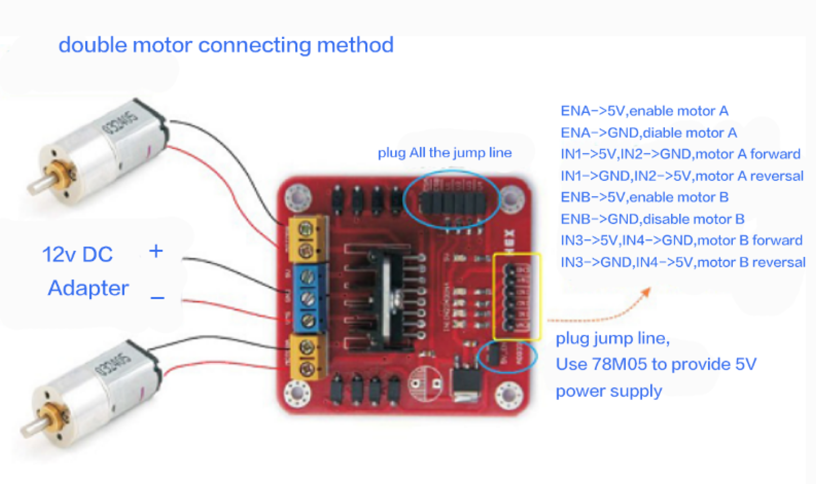
1: motor connection
Motor one connected L298N (MOTOA)
Motor two connected L298N (MOTOB)
2: L298N power supply processing
With 6 section 5 battery box to take the power supply to the L298N motor drive module, the other way to the ARDUINO motherboard power supply,
The L298N motor drive module is powered by a power supply + pole connected to the VMS L298N interface, the power supply - then GND of the L298N
+5V interface, L298N interface board with vent.

First VMS drive part of the power supply can be connected to the external power supply, 9V is generally more appropriate, the logical part of the board to take power,
That the terminal can be suspended, but also access to +5V-+7V. The terminal about three pin two rows were used to control the two DC motor.
EA, EB access ArduinoPWM interface for motor speed control, I1, I2, I3, I4 interface, respectively, to control the DC power
Machine forward, backward, steering and brake, just access to the digital interface Arduino.
Here to work basically completed, you can write an app, I go straight to the car, backward, turn left, turn right, brake work
Can be prepared for the process of order for your reference.
The program as following:
int pinI1=8;//define I1 pin
int pinI2=9;//define I2 pin
int speedpin=11;//define EA(PWM adjust speed)pin
int pinI3=6;//define I3 pin
int pinI4=7;//define I4 pin
int speedpin1=10;//define EB(PWM adjust speed)pin
void setup()
{
pinMode(pinI1,OUTPUT);
pinMode(pinI2,OUTPUT);
pinMode(speedpin,OUTPUT);
pinMode(pinI3,OUTPUT);
pinMode(pinI4,OUTPUT);
pinMode(speedpin1,OUTPUT);
}
void loop()
{
//Go straight
analogWrite(speedpin,100);//Enter the simulation value to set the speed
analogWrite(speedpin1,100);
digitalWrite(pinI4,LOW);//Make DC motor (right) turn clockwise
digitalWrite(pinI3,HIGH);
digitalWrite(pinI1,LOW);//Make DC motor (left) clockwise
digitalWrite(pinI2,HIGH);
delay(2000);
//backward
analogWrite(speedpin,100);//Enter the simulation value to set the speed
analogWrite(speedpin1,100);
digitalWrite(pinI4,HIGH);//Make DC motor (right) turn clockwise
digitalWrite(pinI3,LOW);
digitalWrite(pinI1,HIGH);//Make DC motor (left) counter clockwise
digitalWrite(pinI2,LOW);
delay(2000);
//turn left
analogWrite(speedpin,60);//Enter the simulation value to set the speed
analogWrite(speedpin1,60);
digitalWrite(pinI4,LOW);//Make DC motor (right) turn clockwise
digitalWrite(pinI3,HIGH);
digitalWrite(pinI1,HIGH);//Make DC motor (left) counter clockwise
digitalWrite(pinI2,LOW);
delay(2000);
//turn right
analogWrite(speedpin,60);//Enter the simulation value to set the speed
analogWrite(speedpin1,60);
digitalWrite(pinI4,HIGH);//Make DC motor (right) turn clockwise
digitalWrite(pinI3,LOW);
digitalWrite(pinI1,LOW);//Make DC motor (left) clockwise
digitalWrite(pinI2,HIGH);
delay(2000);
//brake
digitalWrite(pinI4,HIGH);//Make DC motor (right) brake
digitalWrite(pinI3,HIGH);
digitalWrite(pinI1,HIGH);//Make DC motor (left) brake
digitalWrite(pinI2,HIGH);
delay(2000);
}

Note: the procedure I used to turn left and right turn is only a kind of control of the turn, the other way is not a list, we can try.

